Functional Model
System Name: QueueSmart – Digital Waiting System for Hospital Outpatient Services
by
Naga Sai Bolla

1. Use Case Diagram
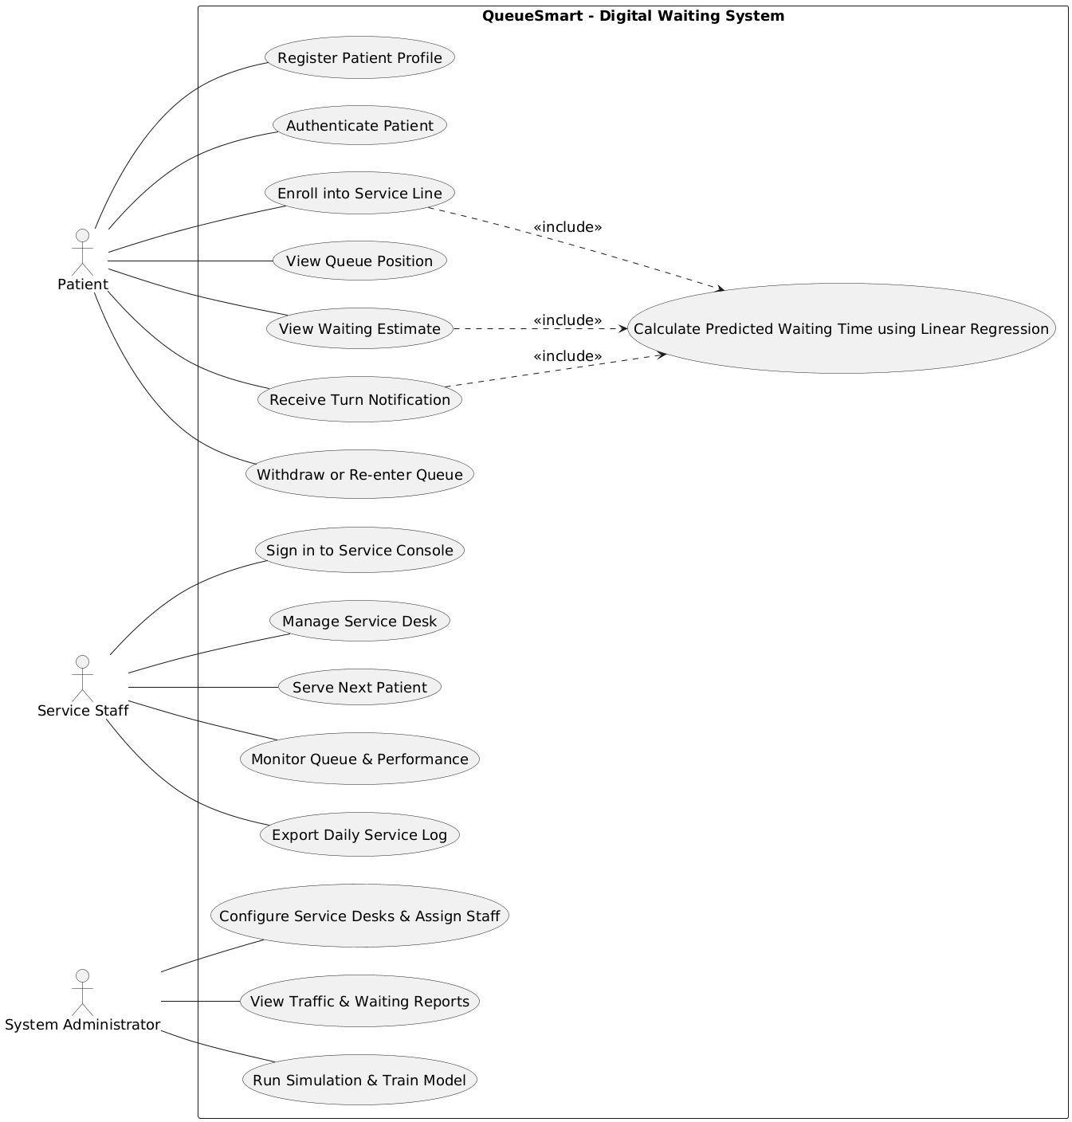Figure.1 Use Case Diagram

2. Use case description
Use Case Name | Register Patient Profile
ID | Use Case 1
Importance Level | High
Primary Actor | Patient
Use Case Type | Primary / User-Initiated
Stakeholders and Interests | Patient wants account access. Hospital wants basic records. System owner wants secure data.
Brief Description | Patient creates a profile to use the system.
Trigger | Patient clicks Register.
Type | External
Relationships | Association: Patient and Register Patient Profile. Include: None. Extend: None. Generalization: None.
Normal Flow of Events | 1. Patient opens the website. 2. Patient selects Register. 3. System shows form. 4. Patient enters details. 5. System saves profile. 6. System confirms registration.
Sub-Flows | S-1: System checks required fields.
Alternate / Exceptional Flows | A-1: Missing details. System shows error. A-2: Username exists. System asks to change.
Related Functional Requirement Number(s) | 1

Use Case 2 Authenticate Patient
Use Case Name | Authenticate Patient
ID | Use Case 2
Importance Level | High
Primary Actor | Patient
Use Case Type | Primary / User-Initiated
Stakeholders and Interests | Patient wants secure access. Hospital wants correct user access.
Brief Description | Patient logs in to the system.
Trigger | Patient selects Login.
Type | External
Relationships | Association: Patient and Authenticate Patient. Include: None. Extend: None. Generalization: None.
Normal Flow of Events | 1. Patient opens login page. 2. Patient enters username and password. 3. System verifies details. 4. System grants access.
Sub-Flows | S-1: System checks login details.
Alternate / Exceptional Flows | A-1: Invalid details. System shows error.
Related Functional Requirement Number(s) | 2

Use Case 3 Enroll into Service Line
Use Case Name | Enroll into Service Line
ID | Use Case 3
Importance Level | High
Primary Actor | Patient
Use Case Type | Primary / User-Initiated
Stakeholders and Interests | Patient wants a queue position. Hospital wants managed flow.
Brief Description | Patient joins a service queue.
Trigger | Patient selects a service desk.
Type | External
Relationships | Association: Patient and Enroll into Service Line. Include: Calculate Predicted Waiting Time. Extend: None. Generalization: None.
Normal Flow of Events | 1. Patient views open desks. 2. Patient selects a desk. 3. System adds patient to queue. 4. System shows queue position and wait time.
Sub-Flows | S-1: System checks desk status.
Alternate / Exceptional Flows | A-1: Desk closed. System shows message.
Related Functional Requirement Number(s) | 8, 22, 23, 24, 25

Use Case 4 View Queue Position
Use Case Name | View Queue Position
ID | Use Case 4
Importance Level | Medium
Primary Actor | Patient
Use Case Type | Primary / User-Initiated
Stakeholders and Interests | Patient wants current position.
Brief Description | Patient views current queue number.
Trigger | Patient opens queue status page.
Type | External
Relationships | Association: Patient and View Queue Position. Include: None. Extend: None. Generalization: None.
Normal Flow of Events | 1. Patient opens status page. 2. System shows position.
Sub-Flows | None
Alternate / Exceptional Flows | A-1: Not in queue. System shows message.
Related Functional Requirement Number(s) | 9

Use Case 5 View Waiting Estimate
Use Case Name | View Waiting Estimate
ID | Use Case 5
Importance Level | High
Primary Actor | Patient
Use Case Type | Primary / User-Initiated
Stakeholders and Interests | Patient wants wait time.
Brief Description | Patient views waiting time.
Trigger | Patient opens wait time view.
Type | External
Relationships | Association: Patient and View Waiting Estimate. Include: Calculate Predicted Waiting Time. Extend: None. Generalization: None.
Normal Flow of Events | 1. Patient opens estimate view. 2. System calculates wait time. 3. System shows estimate.
Sub-Flows | S-1: System updates estimate on change.
Alternate / Exceptional Flows | A-1: Data unavailable. System shows message.
Related Functional Requirement Number(s) | 10, 21, 22, 23, 24, 25

Use Case 6 Receive Turn Notification
Use Case Name | Receive Turn Notification
ID | Use Case 6
Importance Level | High
Primary Actor | Patient
Use Case Type | Primary / System-Initiated
Stakeholders and Interests | Patient wants timely alert. Hospital wants fewer missed turns.
Brief Description | Patient receives turn alert.
Trigger | Queue reaches alert limit.
Type | Internal
Relationships | Association: Patient and Receive Turn Notification. Include: None. Extend: None. Generalization: None.
Normal Flow of Events | 1. System detects queue near turn. 2. System sends alert. 3. Patient receives alert.
Sub-Flows | None
Alternate / Exceptional Flows | A-1: Alert fails. System retries.
Related Functional Requirement Number(s) | 15, 16

Use Case 7 Withdraw or Re-enter Queue
Use Case Name | Withdraw or Re-enter Queue
ID | Use Case 7
Importance Level | Medium
Primary Actor | Patient
Use Case Type | Primary / User-Initiated
Stakeholders and Interests | Patient wants flexibility. Hospital wants accurate queue.
Brief Description | Patient leaves or rejoins queue.
Trigger | Patient selects withdraw or re-enter.
Type | External
Relationships | Association: Patient and Withdraw or Re-enter Queue. Include: None. Extend: Enroll into Service Line. Generalization: None.
Normal Flow of Events | 1. Patient selects withdraw or re-enter. 2. System updates queue.
Sub-Flows | None
Alternate / Exceptional Flows | A-1: Desk closed. System shows message.
Related Functional Requirement Number(s) | 11, 12

Use Case 8 Sign in to Service Console
Use Case Name | Sign in to Service Console
ID | Use Case 8
Importance Level | High
Primary Actor | Service Staff
Use Case Type | Primary / User-Initiated
Stakeholders and Interests | Staff wants access. Hospital wants secure control.
Brief Description | Staff logs in to console.
Trigger | Staff opens staff login page.
Type | External
Relationships | Association: Service Staff and Sign in to Service Console. Include: None. Extend: None. Generalization: None.
Normal Flow of Events | 1. Staff opens login page. 2. Staff enters details. 3. System verifies and grants access.
Sub-Flows | None
Alternate / Exceptional Flows | A-1: Invalid details. System shows error.
Related Functional Requirement Number(s) | 4

Use Case 9 Manage Service Desk
Use Case Name | Manage Service Desk
ID | Use Case 9
Importance Level | High
Primary Actor | Service Staff
Use Case Type | Primary / User-Initiated
Stakeholders and Interests | Staff wants desk control. Hospital wants smooth service.
Brief Description | Staff opens, pauses, or reopens desk.
Trigger | Staff selects desk control.
Type | External
Relationships | Association: Service Staff and Manage Service Desk. Include: None. Extend: None. Generalization: None.
Normal Flow of Events | 1. Staff selects open, pause, or reopen. 2. System updates desk state.
Sub-Flows | None
Alternate / Exceptional Flows | A-1: Desk already in state. System shows message.
Related Functional Requirement Number(s) | 5, 6, 7, 28, 29

Use Case 10 Serve Next Patient
Use Case Name | Serve Next Patient
ID | Use Case 10
Importance Level | High
Primary Actor | Service Staff
Use Case Type | Primary / User-Initiated
Stakeholders and Interests | Staff wants quick service. Hospital wants fast flow.
Brief Description | Staff serves next patient.
Trigger | Staff clicks Next Patient.
Type | External
Relationships | Association: Service Staff and Serve Next Patient. Include: None. Extend: None. Generalization: None.
Normal Flow of Events | 1. Staff selects next patient. 2. System updates queue. 3. Service is completed.
Sub-Flows | None
Alternate / Exceptional Flows | A-1: Queue empty. System shows message.
Related Functional Requirement Number(s) | 13, 14

Use Case 11 Monitor Queue and Performance
Use Case Name | Monitor Queue and Performance
ID | Use Case 11
Importance Level | Medium
Primary Actor | Service Staff
Use Case Type | Primary / User-Initiated
Stakeholders and Interests | Staff wants live status. Hospital wants performance data.
Brief Description | Staff views queue and service stats.
Trigger | Staff opens dashboard.
Type | External
Relationships | Association: Service Staff and Monitor Queue and Performance. Include: None. Extend: None. Generalization: None.
Normal Flow of Events | 1. Staff opens dashboard. 2. System shows queue and averages.
Sub-Flows | None
Alternate / Exceptional Flows | A-1: Data not available. System shows message.
Related Functional Requirement Number(s) | 26, 27, 30, 31

Use Case 12 Export Daily Service Log
Use Case Name | Export Daily Service Log
ID | Use Case 12
Importance Level | Low
Primary Actor | Service Staff
Use Case Type | Primary / User-Initiated
Stakeholders and Interests | Staff wants records. Hospital wants reports.
Brief Description | Staff exports daily log.
Trigger | Staff selects export.
Type | External
Relationships | Association: Service Staff and Export Daily Service Log. Include: None. Extend: None. Generalization: None.
Normal Flow of Events | 1. Staff selects export. 2. System generates file.
Sub-Flows | None
Alternate / Exceptional Flows | A-1: Export fails. System shows error.
Related Functional Requirement Number(s) | 42

Use Case 13 Configure Service Desks and Assign Staff
Use Case Name | Configure Service Desks and Assign Staff
ID | Use Case 13
Importance Level | High
Primary Actor | System Administrator
Use Case Type | Primary / User-Initiated
Stakeholders and Interests | Admin wants setup control. Hospital wants proper setup.
Brief Description | Admin configures desks and staff.
Trigger | Admin opens setup page.
Type | External
Relationships | Association: System Administrator and Configure Service Desks and Assign Staff. Include: None. Extend: None. Generalization: None.
Normal Flow of Events | 1. Admin adds desks. 2. Admin assigns staff. 3. System saves changes.
Sub-Flows | None
Alternate / Exceptional Flows | A-1: Invalid input. System shows error.
Related Functional Requirement Number(s) | 32, 33

Use Case 14 View Traffic and Waiting Reports
Use Case Name | View Traffic and Waiting Reports
ID | Use Case 14
Importance Level | Medium
Primary Actor | System Administrator
Use Case Type | Primary / User-Initiated
Stakeholders and Interests | Admin wants reports. Hospital wants insights.
Brief Description | Admin views reports.
Trigger | Admin opens reports page.
Type | External
Relationships | Association: System Administrator and View Traffic and Waiting Reports. Include: None. Extend: None. Generalization: None.
Normal Flow of Events | 1. Admin opens reports. 2. System shows summaries.
Sub-Flows | None
Alternate / Exceptional Flows | A-1: No data. System shows message.
Related Functional Requirement Number(s) | 34, 35

Use Case 15 Run Simulation and Train Model
Use Case Name | Run Simulation and Train Model
ID | Use Case 15
Importance Level | Medium
Primary Actor | System Administrator
Use Case Type | Primary / User-Initiated
Stakeholders and Interests | Admin wants test data. System owner wants model training.
Brief Description | Admin runs simulation and trains model.
Trigger | Admin selects run simulation.
Type | External
Relationships | Association: System Administrator and Run Simulation and Train Model. Include: Calculate Predicted Waiting Time. Extend: None. Generalization: None.
Normal Flow of Events | 1. Admin starts simulation. 2. System generates data. 3. System trains model.
Sub-Flows | None
Alternate / Exceptional Flows | A-1: Training fails. System shows error.
Related Functional Requirement Number(s) | 38, 39

Use Case 16 Calculate Predicted Waiting Time
Use Case Name | Calculate Predicted Waiting Time
ID | Use Case 16
Importance Level | High
Primary Actor | System
Use Case Type | Included
Stakeholders and Interests | Patients want correct wait time. Hospital wants accurate estimates.
Brief Description | System calculates waiting time.
Trigger | Queue or service data changes.
Type | Internal
Relationships | Association: System and Calculate Predicted Waiting Time. Include: None. Extend: None. Generalization: None.
Normal Flow of Events | 1. System reads queue length. 2. System reads service time. 3. System applies formula. 4. System updates estimate.
Sub-Flows | None
Alternate / Exceptional Flows | A-1: Data missing. System uses last value.
Related Functional Requirement Number(s) | 22, 23, 24, 25

3. Activity Diagram
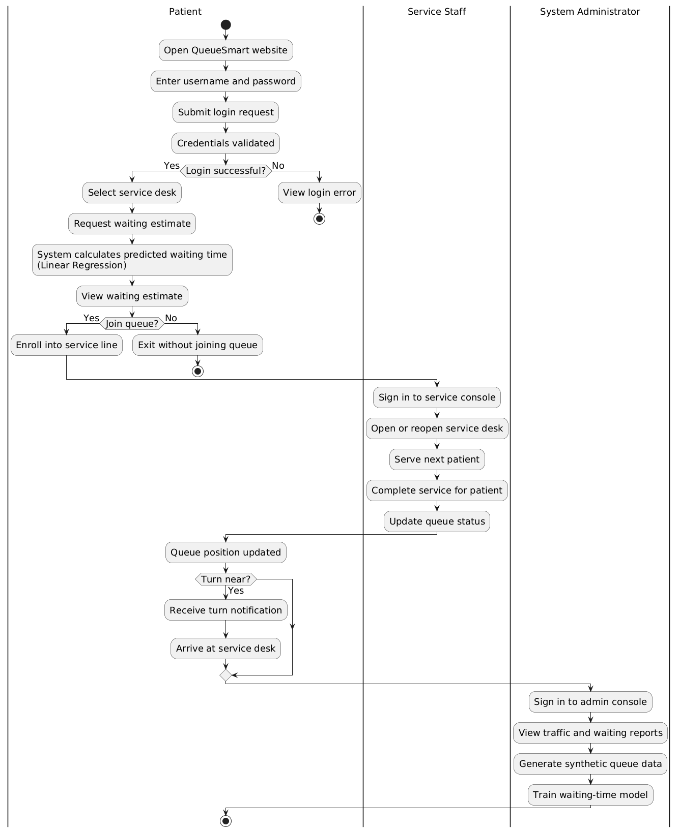
Figure.2 Activity Diagram

